R Script Draft

Team 7

December 13th, 2018

INFM 600

From the dataset PGEEOCS (PG County Equal Employment Opportunity Computer Science), we want to show the total computer related job occupation shared between male and female. Then, we want to select the data that shows occupational category in Computer and Information System. The second picture shows the occupation shared between male and female in Computer and Information System related field.

## MoCo MD tuition Assistance dataset

1 step:

For the department:

which departments are hiring or paying for IT related jobs (1. Filter out majors to represent IT, 2, degree, certificate, non-degree, others, )

For Major:

CS major, C system management, IT, Professional/Technical)

For degree:

Certificate, non-degree, other

2 steps

In r, show us filtering in to majors, and degrees

Run how many departments are hiring from major we selected and degree we selected

How many departments, and how many times each department were asked to attend these classes

## MD Department of Planning, MD County Socialeconomic Characteristics

> PGEEOCS <- read.csv("C:/Users/dyang129/Desktop/INFM 600 Project/PGEEOCS.csv")

> View(PGEEOCS)

>

> > barplot(as.matrix(PGEEOCS),main = "PG County Computer Related Job Distributed by Male and Female", cex.main = 0.9, col = c("blue", "pink"), density = 30, ylab = "Number of Job", xlab = "Job Code", cex.names = 0.6, beside = T)

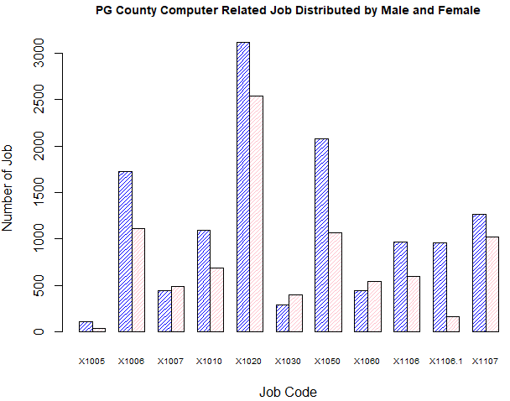

From the dataset PGEEO (PG County Equal Employment Opportunity), we want to show the total job occupation shared between male and female as a reference, to compare it with computer related job occupation. The select data shows total occupation in general. Blue bars represent number of jobs taken by male, and pink bars represent number of jobs taken by female.

setwd("/Volumes/DY JOB RELA/UM 2018 Classes/INFM 600")

> df <- read.table("PGEEO.csv")

> sharedJobs <- c(241625, 251445)

> barplot(sharedJobs, main = "Number of Jobs Shared by Male and Female", names.arg = c("Male", "Female"), beside = TRUE, col = blues9, xlab = "Gender", ylab = "Number of Jobs")

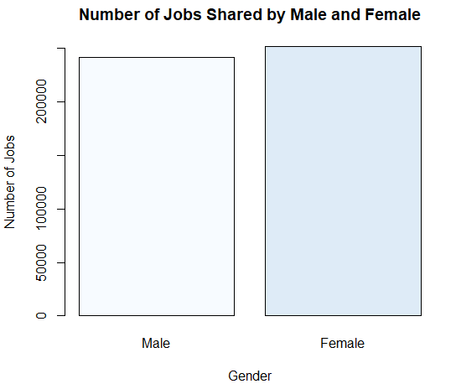

The dataset Maryland Department of Planning, Maryland Counties Socioeconomic Characteristics include all counties in Maryland. We select a few columns that make helps to illustrate the necessity of boot camp for lower income people and minority who do not have resources and would like to enhance they capability in job market.

This should probably just be an infographic about WOC in PG County. This will help us build a profile for the potential need in PG for WOC to do this Bootcamp classes.

Then we will compare those same factors (**Total Households, Employment Status of the Population 16 years and over, Employed, Unemployed, Unemployment Rate, Median Household Income ($), Percent Families in Poverty**) to the rest of the counties as a whole. This will help with our argument that PG is a great place to do this because of its the demorgaphics compared to all the rest of Maryland counties.

> mdSocioEc <- read.csv("/Volumes/DY JOB RELA/UM 2018 Classes/INFM 600/Team Project/USED in Plot/mdSocioEc.csv", header=TRUE)

> View(mdSocioEc)

# to calculate the mean for Median Household Income

> mean(mdSocioEc$MedianHouseholdIncome)

[1] 70159.42

> # to see relationship between HS diploma with Female

> x1 <- mdSocioEc$High.School.Diploma

> y1 <- mdSocioEc$Female

> plot(x1, y1, col="blue", main = "Female with HS Diploma Regression", abline(lm(y1~x1)), xlab = "HS Diploma", ylab = "Felame" )

> lm(formula = y1~x1)

Call:

lm(formula = y1 ~ x1)

Coefficients:

(Intercept) x1

-9234.675 3.198

> relation1 <- lm(formula = y1~x1)

> summary(relation1)

Call:

lm(formula = y1 ~ x1)

Residuals:

Min 1Q Median 3Q Max

-61180 -18678 -5205 -893 224991

Coefficients:

Estimate Std. Error t value Pr(>|t|)

(Intercept) -9234.6748 15472.0194 -0.597 0.557

x1 3.1979 0.2475 12.918 9.53e-12 ***

---

Signif. codes: 0 ‘***’ 0.001 ‘**’ 0.01 ‘*’ 0.05 ‘.’ 0.1 ‘ ’ 1

Residual standard error: 55090 on 22 degrees of freedom

Multiple R-squared: 0.8835, Adjusted R-squared: 0.8782

F-statistic: 166.9 on 1 and 22 DF, p-value: 9.526e-12

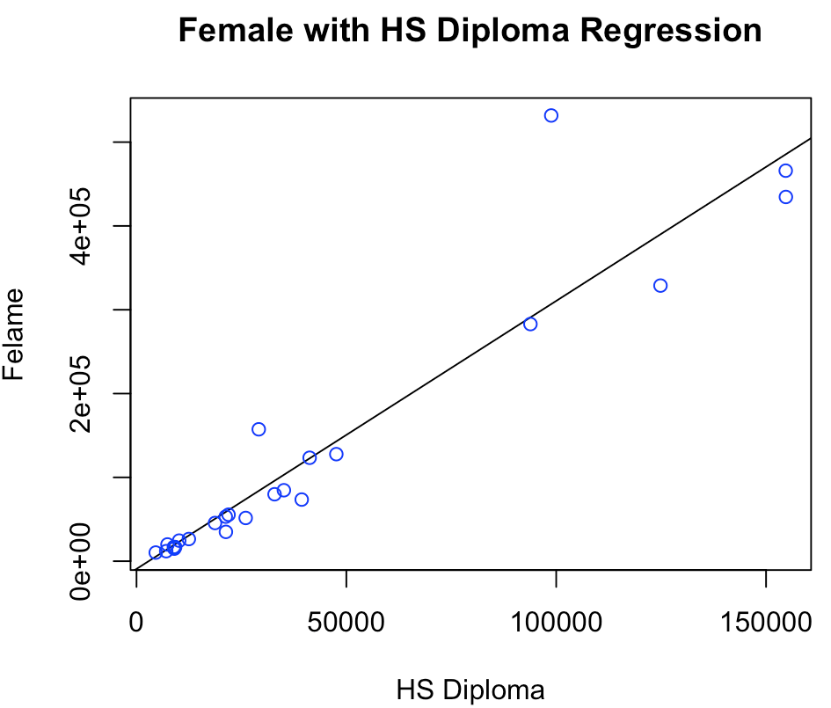

> # here we want to see the relationship between unemployed and family in provity

> x2<- mdSocioEc$Unemployment.Rate

> y2 <- mdSocioEc$PercentFamiliesinPoverty

> relation2 <- lm(y2~x2)

> lm(formula = y2~x2)

Call:

lm(formula = y2 ~ x2)

Coefficients:

(Intercept) x2

-4.395 1.851

> summary(lm(y2~x2))

Call:

lm(formula = y2 ~ x2)

Residuals:

Min 1Q Median 3Q Max

-6.6392 -1.5311 -0.5254 0.8640 9.4505

Coefficients:

Estimate Std. Error t value Pr(>|t|)

(Intercept) -4.3953 2.2947 -1.915 0.0685 .

x2 1.8506 0.3305 5.600 1.25e-05 ***

---

Signif. codes: 0 ‘***’ 0.001 ‘**’ 0.01 ‘*’ 0.05 ‘.’ 0.1 ‘ ’ 1

Residual standard error: 2.98 on 22 degrees of freedom

Multiple R-squared: 0.5877, Adjusted R-squared: 0.569

F-statistic: 31.36 on 1 and 22 DF, p-value: 1.249e-05

> plot(x2, y2, col="blue", main = "Percent of Unemployed and Percent of Family in Proverty Regression", abline(lm(y2~x2)),cex.main = 0.8, xlab = "Percent Unemployed", ylab= "Percent Family in Poverty")

Since the P value is very small, so the X2 is very significant.

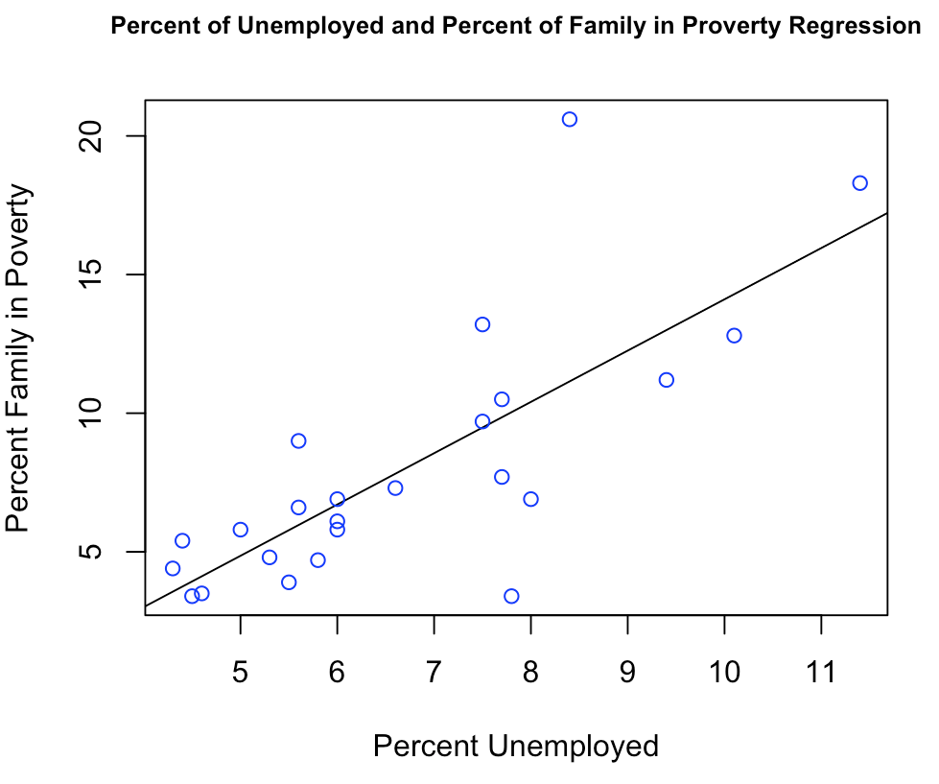

Race in PG County

> PGRace <- c(173881, 570138, 38063, 3449, 269, 86885, 25008, 150268)

> barplot(PGRace, main = "PG County Race", xlab = "Race", ylab = "Population", names.arg = c("White", "Black", "Asian", "Indian/Alaska", "Hawaiian", "Others", "Mix", "Hispanic"), col = "blue", density = 10, cex.names = 0.6)

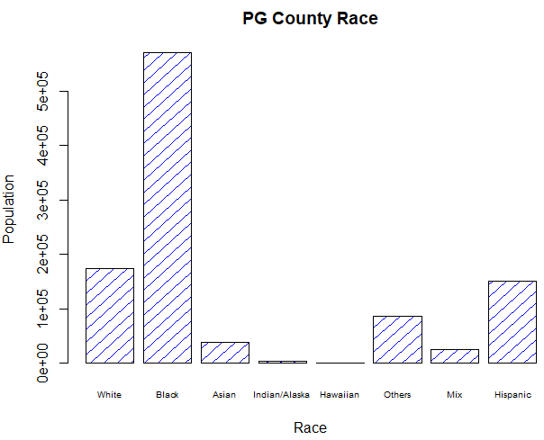

MD IT Tuition Assistance

> MDITTuitionAssistance <- read.csv("E:/UM 2018 Classes/INFM 600/Team Project/USED in Plot/MDITTuitionAssistance.csv")

> View(MDITTuitionAssistance)

> CostAssistance <- as.numeric(MDITTuitionAssistance$Cost)

> mean(CostAssistance)

[1] 703.8842

> > MarylandTuitionAssistance <- read.csv("E:/UM 2018 Classes/INFM 600/Team Project/USED in Plot/MarylandTuitionAssistance.csv")

> View(MarylandTuitionAssistance)

> summary(MarylandTuitionAssistance)

Department Major

:1045760 :1045760

Correction & Rehabilitation: 2 Computer Science : 4

Health & Human Services : 2 Computer Systems Management: 3

Housing & Community Affairs: 1 Information Technology : 15

Police : 11 Professional/Technical : 2

Technology Services : 4

Transportation : 4

Degree Cost

:1045760 Min. : 0.0

Certificate: 13 1st Qu.: 335.3

Non-Degree : 4 Median : 412.0

Other : 7 Mean : 703.9

3rd Qu.: 984.0

Max. :2130.0

NA's :1045760

## For the State of Maryland, there are only 6 department offered 24 tuition assistantship for the computer science related major. Among these computer related training, 13 of them are for certificate, 4 of them are non-Degree, and 7 for all others. The mean of the tuition assistance is $703.90, which is very limited to employee career development. For people who live in PG county, there is highest number of minority live in the county.

> mdSocioEcMinSum <- read.csv("C:/Users/dyang129/Desktop/Team Project/USED in Plot/mdSocioEcMinSum.csv")

> View(mdSocioEcMinSum)

> summary(mdSocioEcMinSum)

Jurisdictions Total.Households MedianHouseholdIncome

Allegany County : 1 Min. : 7683 Min. : 35886

Anne Arundel County: 1 1st Qu.: 17459 1st Qu.: 52839

Baltimore city : 1 Median : 38074 Median : 68464

Baltimore County : 1 Mean : 90729 Mean : 70159

Calvert County : 1 3rd Qu.: 96841 3rd Qu.: 86873

Caroline County : 1 Max. :367764 Max. :113800

(Other) :18

Families PercentFamiliesinPoverty Male Female

Min. : 4654 Min. : 3.400 Min. : 9539 Min. : 10280

1st Qu.: 12622 1st Qu.: 4.775 1st Qu.: 22547 1st Qu.: 23405

Median : 27000 Median : 6.750 Median : 52890 Median : 54331

Mean : 60665 Mean : 7.996 Mean :120281 Mean :128049

3rd Qu.: 70418 3rd Qu.: 9.900 3rd Qu.:129332 3rd Qu.:135112

Max. :256128 Max. :20.600 Max. :494612 Max. :531759

WhiteAlone totalMinority

Min. : 13719 Min. : 1136

1st Qu.: 39742 1st Qu.: 10349

Median : 80771 Median : 23944

Mean :142010 Mean :129242

3rd Qu.:184673 3rd Qu.:102525

Max. :566239 Max. :874080

> pie(pgSocioEcEdu$numberOfPpl, labels = row.names(pgSocioEcEdu$eduLevel), main = "PG County Education Level")

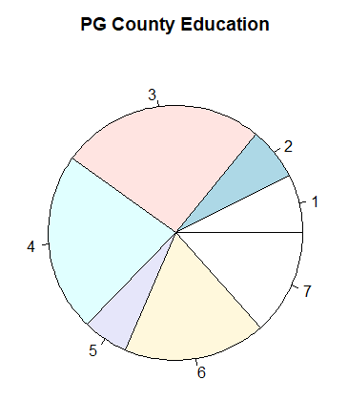

In the PG County Socialeconomic Education dataset, there are 7 education level, ranged from “less than 9th Grade” to “Graduate or Professional” level. We will attached the name to each share of the pie later. The share 3 and 4 represent high school diploma and some college without degree. It almost occupied half of the population. These people do have some knoledge and still trainable. We should give them the opportunity to enhance their skills so that it will provide benefit for their future career.

> mdpgSocioEcEduTotal <- read.csv("C:/Users/dyang129/Desktop/Team Project/USED in Plot/mdpgSocioEcEduTotal.csv", header=TRUE)

> View(mdpgSocioEcEduTotal)

> barplot(as.matrix(mdpgSocioEcEduTotal), main = "Maryland and PG County Education", col = c("blue", "red"),density = 60, xlab = "Education Level", ylab = "Number of People",cex.names = 0.5,beside = T)

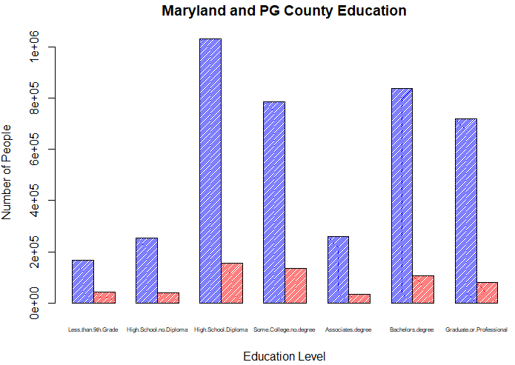

hist(TA$Cost)

This gives us the below histogram which shows that if cost of a major is higher then fewer people opt for it and vice versa.

This is a right-skewed distribution.

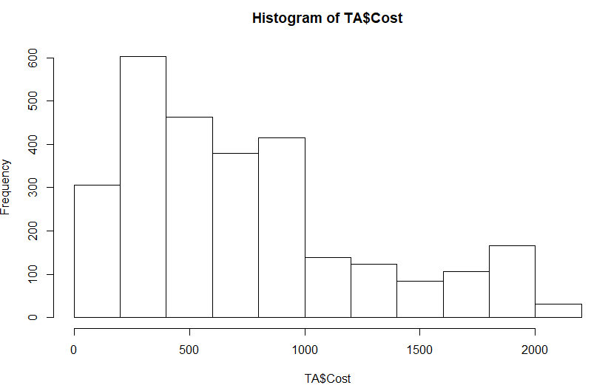

We use unique(TA$Major) to get infer that there are 79 different majors people are opting for

aggregate(TA$Cost, list(Major = TA$Major), mean)

 Major         x

1                                             Accounting (Business) 645.2757

2                                             Aerospace Engineering 940.0000

3                                          African-American Studies 366.0000

4                                              Agricultural General 168.0000

5                       Animal Sciences: Animal Care and Management  403.3333

6                                                      Architecture 325.6000

7                                                     Art Education 372.0000

8                                                       Art History 305.0000

9                                                    Bioengineering 1830.0000

10                       Biological Sciences: Ecology and Evolution  354.0000

11                             Biological Sciences: General Biology  686.6667

12                                            Business/Admin./Mgmt. 775.9929

13                   Central European, Russian and Eurasian Studies  482.5000

14                              Civil and Environmental Engineering  452.5500

15                                                    Communication 595.6875

16                                                 Community Health 1343.6667

17                                             Computer Engineering 380.4000

18                                                 Computer Science 674.9217

19                                      Computer Systems Management 588.6538

20                                                 Criminal Justice 697.0933

21                                 Criminology and Criminal Justice 771.2214

22                                        Early Childhood Education 1013.7500

23                                    Education (Teacher:Undecided) 1435.2500

24                                           Electrical Engineering 452.0000

25                                             Emergency Management 654.0522

26                                          Engineering (Undecided) 639.6500

27                                  English Language and Literature 720.9350

28                        Environmental Science and Policy (Policy) 1881.0000

29                       Environmental Science and Policy (Science)  878.0000

30                   Environmental, Educational and Park Management 1077.8571

31                                                   Family Studies 1464.0000

32                                               Finance (Business) 1352.4667

33                                      Fire Protection Engineering 630.6167

34                                                     Fire Science 502.8623

35                                                 Forensic Science 1402.1429

36                                  General Business and Management 1306.6667

37                                                  General Studies 383.8517

38                                                        Geography 535.4250

39                                          Government and Politics 1273.7143

40                                          Health & Human Services 789.3700

41                                                          History 654.3997

42                                                  Human Resources 720.5636

43                                                             HVAC 364.4750

44                                               Individual Studies 735.0000

45                                     Information Systems-Business 1150.6667

46                                           Information Technology 910.1266

47                                           International Business 813.0000

48                                                      Job Related 954.9978

49                                                              Law 1022.2646

50                                        Liberal Arts/Gen. Studies 185.3333

51                                                      Linguistics 577.5000

52 Logistics, Transportation and Supply Chain Management (Business) 1374.0000

53                                             Marketing (Business) 749.0000

54                                                      Mathematics 810.5000

55                                           Mechanical Engineering 1107.4375

56                                                             None 745.8185

57                                                       Not Listed 756.3678

58                                                    Not Specified 686.5805

59                                                          Nursing 746.9164

60                                             Nutritional Sciences 501.0833

61                                 Operations Management (Business) 1041.8000

62                                                      Other/Misc. 769.2516

63                                                Paralegal Studies 442.3429

64                                               Physical Education 386.0000

65                                                Political Science 947.4545

66                                           Pre-Medical Technology 292.0000

67                                                      Pre-Nursing 347.2222

68                                           Professional/Technical 520.7143

69                                                       Psychology 704.3370

70                                            Public Administration 1196.2807

71                                                    Public Safety 976.4076

72                                  Russian Language and Literature 1830.0000

73                                                Science Education 585.0000

74                                         Social Studies Education 1930.0000

75                                                      Social Work 982.5535

76                                                        Sociology 607.9000

77                                  Spanish Language and Literature 909.6860

78                                 Undecided (Letters and Sciences) 240.0000

79                                                   Urban Forestry 528.0000

From this data set we subset the data amongst two excel sheets TA3 & TA4 such that TA3 has all non-computer/data science courses and TA4 has all computer and data science related courses.

Now using R script

mean(TA3$Cost) =

|  |
| --- |
| 791.5187351  mean(TA4$Cost) = 740.95376  It is astonishing that computer/data science related courses actually cost lesser |